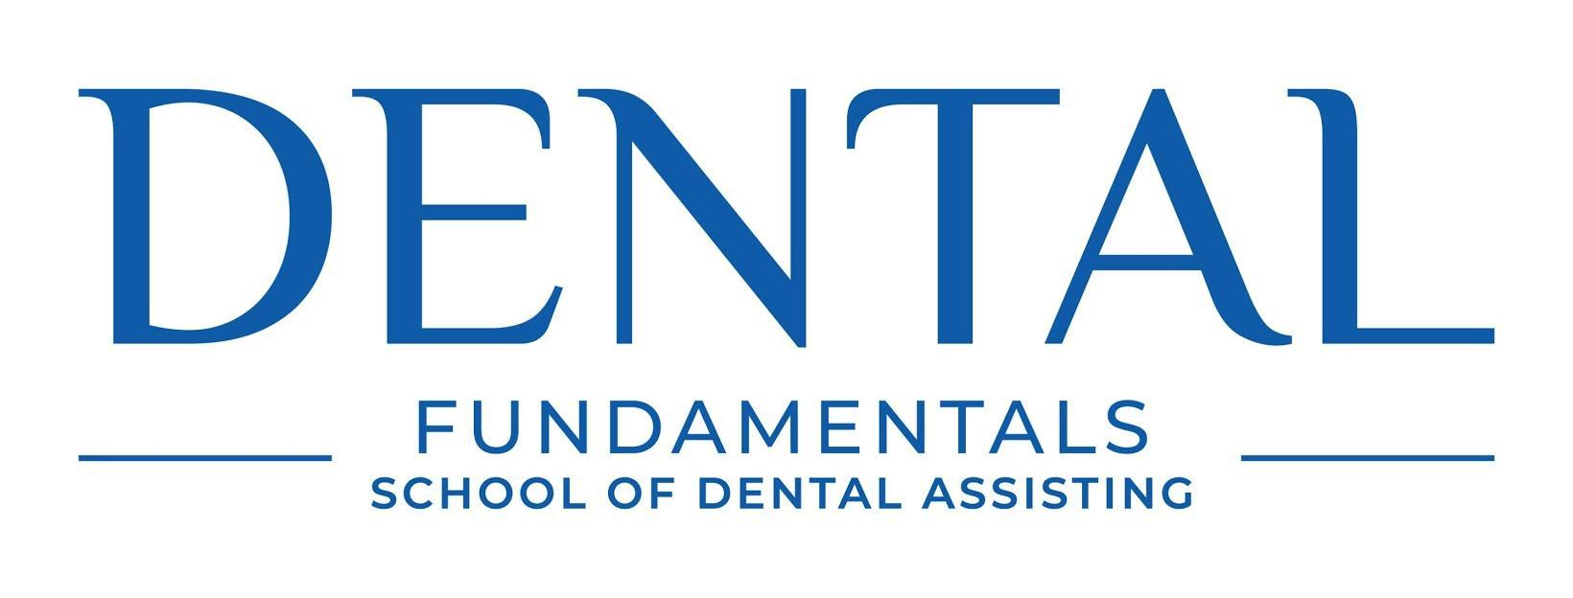
622 E. 4500 S. Suite #101 SLC, UT 84107
phone: (801) 419-7311 Email: dentalfundamentals.slc@gmail.com

ENROLLMENT AGREEMENT

Name |  |  | Social Security Number |  |  | Date
Address |  | City |  |  | State | Zip
Date of Birth  Email_____________________ | Primary Phone Number |  |  | Alternate/Cell Phone Number
Program Start Date |  |  | Program End Date

PROGRAM SUMMARY AND INTRODUCTION
The Dental Assisting Program is a 10-week program designed to provide the student with the essential skills to function at an entry level position as a dental assistant in a general dental practice. Graduates of the program receive a Certificate of Completion and Radiology Certification Certificate. Classes are offered on Monday & Wednesday evenings from 5:30 pm until 9:30 pm, or Fridays from 9am until 3pm. Additional externship hours may be required to obtain a total of 80 clock hours in the program.

Dental Fundamentals of Salt Lake City is a Private Occupational School owned by Jason Skinner, DDS.

Faculty Members
Jason Skinner D.D.S - Owner
J.J. Kerry - Lead Instructor/ Administrator

PROGRAM/COURSE CURRICULUM
Emphasis will be placed on eight core essential skills of Dental Assisting which include:

- Taking X-rays
- Developing and mounting X-rays
- Alginate impressions
- Pouring up stone casts
- Rubber dam placement
- Bands and wedges
- Four-handed dentistry
- Fabricating temporary crowns

Classroom, Lecture, Personal Study and Externship will include, but will not be limited to:
- Anesthesia
- Sealants
- Basic instruments
- Meet, greet and seat
- Role in keeping a dry field
- Bleach trays
- Oral hygiene instructions and periodontal maintenance
- Crown and bridge
- Specialties of dentistry, oral surgery and removable prosthodontics
- Cleaning of operatory room
- Endodontic treatment root canals
- OSHA
- Mixing cements, bases and liners
- The professional dental assistant
- Amalgam restorations
- Composite restorations
- Patient charting and basic laboratory equipment

CLASS SCHEDULE
Classes will be held on Mondays and Wednesdays from 5:30pm until 9:30pm, or Fridays from 9am until 3pm.
Externship hours will be required after the fifth week of class has been completed. All externships must be performed on student’s own time outside of class. Students will receive a current schedule at the time of enrollment with any dates that classes will not be held. When an unexpected closure occurs due to extraordinary conditions such as inclement weather, students will be notified by phone.

POSTPONEMENT OF START DATE
Dental Fundamentals does not allow students to postpone start dates. In the event that a student is unable to start on their scheduled start date, they may be asked to start on the next available new class start date. Students are entitled to a full refund up to when they start the program. (See refund policy)

PROGRAM ENTRANCE AND ENROLLMENT PROCESS
Dental Fundamentals School of Salt Lake City will accept applicants for admission on a first come, first serve basis. Dental Fundamentals School of Salt Lake City will not discriminate against any applicant on the basis of race or ethnicity. The requirements for admission to the program are as follows:

- Submit a completed application and copy of high school diploma or General Education Development (GED) Certificate to Dental Fundamentals. Applicant must be beyond the age of compulsory high school attendance, as prescribed by Utah law. If you have not graduated from high school or received a GED then you may be required to take an entrance exam to be eligible for the course. No one under the age of sixteen will be allowed in the course.
- Submit non-refundable application fee of $50.00 to Dental Fundamentals of Salt Lake City.
- Participate in a short interview with school administrator.
- Applicants will be notified upon acceptance by Dental Fundamentals of Salt Lake City.

PREVIOUS CREDITS
Dental Fundamentals School of Salt Lake City will not grant any credit, reduction in hours or reduction in tuition toward its program for any previous education or training completed at any other institution.

TUITION, FEES AND REQUIREMENTS
Registration fee: $50.00. Registration fee is due with a completed application for admission and is non-refundable.
Tuition for 10-week course: $3,250.00. Tuition includes equipment use and supplies associated with the program. Book supplies are $150.00. The total cost of the program is estimated to be $3,450.00

Full payment of tuition is due prior to the first day of class. If payment is not received prior to the first class, the student may not participate. Any financing arrangements must be made prior to first day of class and must continue to be current or class may be terminated.

STUDENT RESPONSIBILITIES
All students must show the school proof that he/she has completed the first series of the Hepatitis B vaccination prior to commencement of classes. Documentation letter from a physician or health clinic may be required.

To facilitate training and education, students may be required to perform various procedures including impressions and some radiographs on classmates. By signing this enrollment agreement, students understand that they may be asked and agree to participate in these procedures.

CANCELLATION AND REFUND POLICY
A three-business-day cooling-off period, commencing with the day an enrollment agreement with the applicant is signed or payment toward tuition and fees of the school is made, until midnight of the third business day following such date or from the date that the student first visits the school, whichever is later, during which time the contract may be rescinded and all monies paid refunded. Evidence of personal appearance at the institution or deposit of a written statement of withdrawal for delivery by mail or other means shall be deemed as meeting the terms of the cooling-off period.
Students will receive a full refund of tuition and fees paid if the school discontinues it’s program for a period of time in which the student could have reasonable completed it, except that this provision shall not apply in the event the school ceases operation.
The policy for granting credit for previous training shall not impact the refund policy
Once a student has started the program, partial refunds will be as follows:

- Between Week 1 and Week 3 of program: 50% of tuition
- After Week 3 of program: Student is entitled to no refund
- All refunds will be made within 30 days from the date of termination

The school maintains a form of surety bond as part of the registration with the Division

ATTENDANCE POLICY
Students are expected to arrive on time for class with proper materials. An overall attendance rate of at least 100% is required. Instructors may request your withdrawal from the program if absences or tardiness exceed 70%. Students who are unable to continue classes for medical reasons or severe personal problems will be required to take a leave of absence until they are able to return to class. Proper documentation will be required to substantiate a student’s withdrawal. No fees will be assessed due to absences. Although all course work must be made up in order to graduate with all certifications.

CONDUCT AND DISMISSAL POLICY
All students are expected to act maturely and are required to respect other students and faculty members. Possession of weapons, illegal drugs, and alcohol of any kind are not allowed at any time on school property. Any violation of school policies may result in permanent dismissal from school without a refund. DISMISSAL: Any student may be dismissed for violation of rules and regulation of the school, as set forth in school publications. A student also may be withdrawn from classes if he or she does not prepare sufficiently, neglects assignments, or makes unsatisfactory progress. The director, after consultation with all parties involved, makes the final decision. The director of education may temporarily suspend students whose conduct is disruptive or unacceptable to the academic setting. After appropriate counseling, student who demonstrate a genuine desire to learn and conform to school standards of conduct, may be allowed to resume attendance. The director will review each case and decide upon re-admittance.

GRADING AND PROGRESS POLICY
Students must maintain a 75% grade point average. Those who do not will be placed on probation for 30 days. During the probation period students must raise their grade average to passing or higher. The student may be terminated if grades are not satisfactory at the end of the probationary period. Termination shall be at the school Director’s discretion. The director has final authority and shall notify the student of the final decision.
Laboratory testing will be evaluated on three performance levels (Excellent, Satisfactory and Unsatisfactory). All laboratory testing must be passed with an Excellent or Satisfactory level of proficiency.

FACILITIES
Dental Fundamentals of Salt Lake City is located at. 622 E. 4500 S. Suite #101, SLC, UT 84107. Our course is taught out of a General Dentist office equipped with modern dental equipment and supplies to assist student learning. Equipment may include computers with powerpoint presentations, x-ray units, dental chairs, handpieces, basic laboratory equipment, and manikins for hands-on training.

GRADUATION REQUIREMENTS
Students may graduate the program upon passing required written and lab proficiency exams, as well as completing the 80-hour course within the allotted 10-week period. Student must have complied with the Attendance policy as stated above. Upon graduation student will receive a Certificate of Completion CPR and Radiology Certification.
Our current Graduation rate is 100%, and our current employment rate after graduation is 93%

PLACEMENT ASSISTANCE
Dental Fundamentals of Salt Lake City may offer employment assistance to graduates, consisting of job lead referrals and job skills development. This may include interpersonal, resume and interviewing skills. While assisting in your job search we make no guarantee, expressed or implied, of future employment. Current law prohibits any school from guaranteeing job placement as inducement to enroll students.

COMPLAINTS AND INQUIRIES
Student seeking to resolve problems should: 1) discuss the problem with the instructor. 2) If student still feels like the problem is unresolved then they should contact Dr. Jason Skinner D.D.S at 622 E. 4500 S. Suite #101, SLC, UT 84107. All complaints must be in writing and can be hand delivered to those who work at the school. Letters to Dr. Jason Skinner must be sent by certified mail. Attempting to resolve any issue with the school is strongly encouraged. Student complaints may be brought to the attention of the Division of Consumer Protection 160 E 300 S 2nd floor Salt Lake City, UT 84114 or by fax to: (801) 530-6001

REGISTERED UNDER THE UTAH POSTSECONDARY PROPRIETARY SCHOOL ACT (Title 13, Chapter 34, Utah Code) DONE
Registration under the Utah Postsecondary Proprietary School Act does not mean that the State of Utah supervises, recommends, nor accredits the institution. It is the student’s responsibility to determine whether credits, degrees, or certificates from the institution will transfer to other institutions or meet employers’ training requirements. This may be done by calling the prospective school or employer. The institution is not accredited by a regional or national accrediting agency recognized by the United States Department of Education.

I, the undersigned, have read, understand and agree to abide by all the provisions set forth in the foregoing enrollment agreement.

Applicant Name | Date
School Official | Date

